Fact sheet
September 2022

Keeping chickens for egg production in Broken Hill
Lead does not belong in the human body. When it gets into our bodies, it can make high blood pressure worse and cause kidney problems. Lead can also harm kids’ brain development, which may cause behaviour and learning problems that can last a lifetime.

One of the ways lead can get into the human body is by eating eggs or chickens that have been raised on lead-contaminated soil.

Hens scratch in the dirt and peck food from the ground, and the lead can then transfer into the chickens themselves and their eggs.

Research suggests that lead contamination of soils at the levels typically found in Broken Hill may result in unacceptable levels of lead in eggs raised for eating.

How to keep chickens in Broken Hill
It is still possible to eat the eggs from chickens raised in Broken Hill, if you follow some simple precautions.
- Keep chickens on clean soil
- Keep chickens away from areas that may have been contaminated by lead-based paint (like sheds and outbuildings, fences, and areas where old building materials have been stored)

Examples of good chicken-keeping practices
- Put 200 mm of clean soil on top of a barrier such as shade cloth to prevent the chickens from accessing the soil below. If you live close to the mines, get your soil lead levels checked every few years and replace soil as necessary.
- Build your chicken yard with a concrete floor, and a 100-150 mm layer of straw, wood shaving or rice hulls. Provide a large shallow pan such as a litter tray or wading pool filled with clean soil or sand for dust bathing.
- Ensure your chicken yard is constructed of lead-free materials

Sand and loam that’s OK to use is available from
Mawson’s Quarry in Broken Hill and is regularly
screened for lead as part of the Broken Hill
Environmental Lead Program (BHELP)

BHELP will test your soil where you keep your chickens free of charge.
- Place approximately one cup of soil from your chicken yard in a zip lock bag.
- Clearly label the bag with your name, residential address, and email address for results.
- Deliver to BHELP, level 2, 32 Sulphide Street, Broken Hill – Mondays only between 9am – 12
- Allow a 2 – 3 weeks turn around for results

If your soil is found to be contaminated then BHELP is able to advise on measures you can take to remediate your property.

NSW Environment Protection Authority
Email: info@epa.nsw.gov.au
Website: www.epa.nsw.gov.au
BHELP website: www.leadsmart.nsw.gov.au
The EPA disclaimer and copyright information is available on the EPA website.
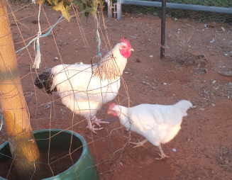
Cecil and Hedvig: photo credit Frances Boreland

Yazdanparast T, Strezov V, Peter Wieland a , Lai Y , Jacob DE, Taylor MP. Lead poisoning of backyard chickens: Implications for urban gardening and food production. Environmental Pollution 2022, 310:119798

